Project Management

Assessment ONE

yesid giron giron in wells college

|  |  |  |  |
| --- | --- | --- | --- |
| Name of Student | YESID ALBERTO GIRON GIRON | ID | 70403 |

**Assessment 1 – Case Study**

Contents

Instruction: 2

Duration: 2

Case Study: 2

Going Green application, Green IT Project Management 2

Project profile 2

Here is my software running on my phone! Or Access by: 4

Business situation 4

Your tasks: 5

Task 1: Identify Business Strategy and Gap 5

Analyse Strategy 5

Task 2: Recommend a feasible solution 6

Task 3: Produce a Project Charter 6

Task 4: Project Document 8

Task 5: Project Closure 9

Helpful web links to complete the assessment: 12

Search Index 13

## Instruction:

This task is to be completed individually. You need to analyse a case scenario and complete all the tasks mentioned after the scenario.

You need to demonstrate your IT project management ability to identify business strategy and gaps. You will also need to suggest a feasible solution to overcome identified gaps and produce a project charter along with a WBS to implement the proposed solution.

### Duration:

Trainer will set the duration of the assessment.

All my working could be checked <https://wellsjohn220.github.io/pmt32023by12345>

## Case Study:

### Going Green application, Green IT Project Management

# Project profile

Going “Green” is a mission of many companies around the globe not just for reasons of environmental responsibility, but also for cutting costs in these extremely tight economic times. Green IT efforts represent a specific focus area within enterprises that hold attention to this trend. Green IT leverages information technology to streamline operations, cut costly waste, and reduce the impact on the environment. IT typically consumes only about 10% of an organization’s energy costs, but the net effect of a Green IT project is to go beyond just energy saving. To tackle the other 90%, a Green IT project extends into a variety of other departments, and to execute such an endeavour requires an effective project management function in order to identify and prioritize goals. A Green IT transformation can be a complex process.

Vital Statistics:

* Number of project tasks - 12
* Project duration - 16 months
* Project budget - $1,200,000
* Number of users - 50

Because I could not get Ms-Project software. I use google Sheets to made Gantt chart template:

I also think using a simple case, which I knew well, could be better for my learning. Go to website:

Link URL: <https://docs.google.com/spreadsheets/d/1FKGZUtobBdEyA22cImz176jYuQU68G9CBRHwJqLayPA/edit?usp=sharing>

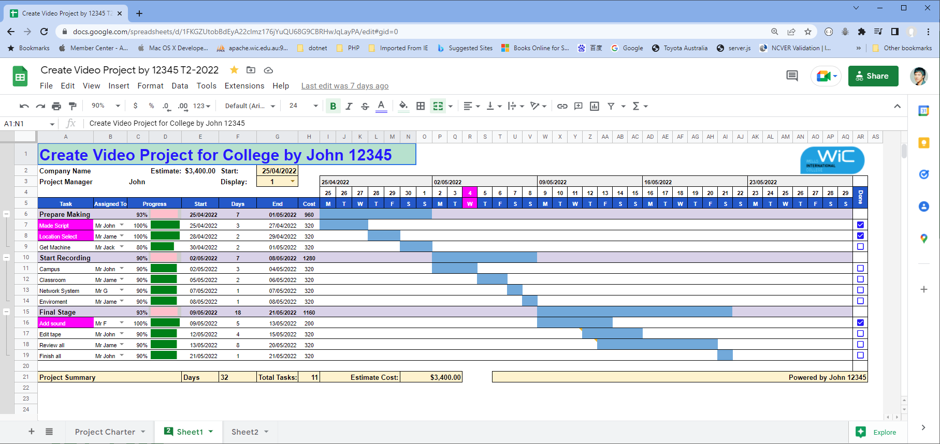

Tutor reference: <https://www.youtube.com/watch?v=8eKk0M2zGIk>

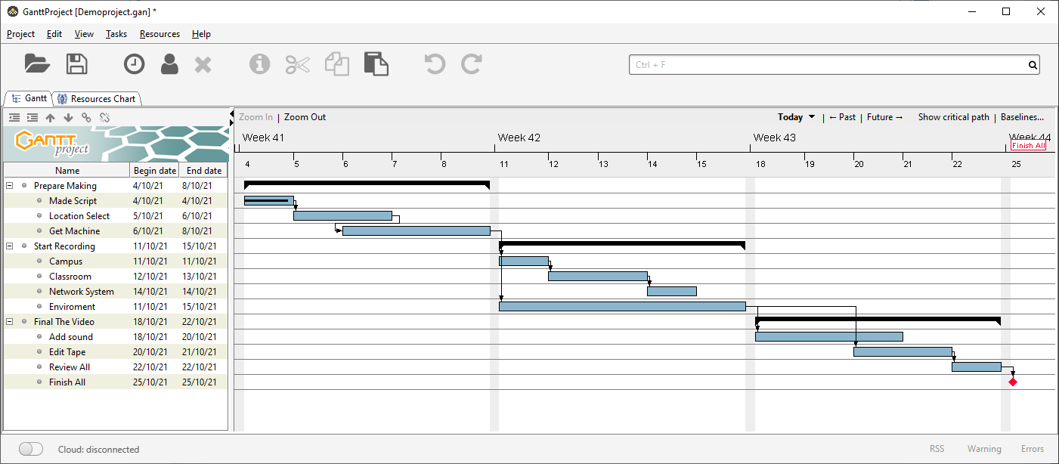

<https://wellsjohn220.github.io/projectwebsite/Demoproject-chart.html>

### 

### Business situation

Sample Summary Report:

In order help college promotion, the college need good video film. I set the project and start it now…

…

## Your tasks:

### Task 1: Identify Business Strategy and Gap

Document the business’s strategies of “Green IT” and also summarise the components required changes for the participating organisation to implement “Green IT Project”.

Business strategy is a planning function of any organisation. Business strategy incorporates having a strategic plan.

A business strategy is indeed a crucial planning function for any organisation. In the context of "Green IT", the business strategy would involve a comprehensive plan to incorporate sustainable and environmentally friendly practices into the organisation's IT infrastructure and operations.

The first step in the "Green IT" strategy is to conduct an environmental audit of the current IT infrastructure. This includes assessing the energy efficiency of servers, computers, and other hardware, as well as the carbon footprint of data centers. The audit should also consider the lifecycle of IT equipment, from manufacturing and use to disposal. Once the audit is complete, the organisation can identify areas for e improvement and set specific, measurable goals for reducing its environmental impact. This could involve strategies such as improving energy efficiency, reducing e-waste, promoting recycling, and sourcing from sustainable suppliers.

Implementing a "Green IT" project requires several key components. Firstly, there needs to be a commitment from senior management to support the project and allocate necessary resources. This includes appointing a project manager with experience in sustainability initiatives.

Secondly, the organisation needs to invest in energy-efficient hardware and software. This could involve upgrading servers, investing in virtualisation technology to reduce the number of physical servers required, or switching to cloud-based services.

Thirdly, the organisation should implement policies and procedures to promote sustainable practices among employees. This could include training programs, incentives for reducing energy use, and guidelines for responsibly disposing of e-waste.

Finally, the organisation should regularly monitor and evaluate its progress towards its "Green IT" goals. This will allow it to identify any issues or challenges that arise and adjust its strategy as needed.

In conclusion, implementing a "Green IT" strategy requires a comprehensive approach that involves auditing current practices, setting clear goals, investing in sustainable technology, promoting sustainable practices among employees, and regularly evaluating progress. With commitment and planning, organizations can significantly reduce their environmental impact and contribute to a more sustainable future.

The strategic plan of an organisation sets out the goals a business hopes to achieve within a specified period of time. It also helps the organisation understand the environment within which they operate and the market forces that affect them.

An analysis of the current strategic plan enables you to understand the goals of your organisation. However, in order to analyse the strategic plan, you first need to understand the structure and purpose of a strategic plan. This topic describes the elements that make up a strategic plan.

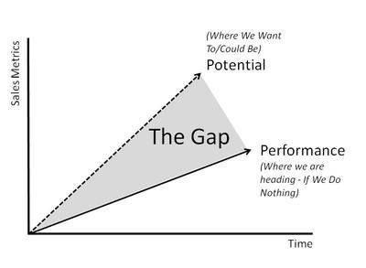The green project we need defined every requirement. The gap which is between your plan and reality always need your notice. So you need do your best to investigate your Green Project.

### Task 2: Recommend a feasible solution

Assume “Wells International College” is thinking of going “Green” and asked for your assistance in this project. Research different project management applications on the Internet to compare with the Green IT project management application and recommend a feasible solution with proper reasons for Windsor. (Min. 300 words)

Wells International College's initiative to go "Green" is commendable. Implementing a Green IT project requires careful planning and management. To ensure the success of this project, it's crucial to choose a project management application that aligns with the college's needs and goals.

There are several project management applications available that could be suitable for managing a Green IT project. Here are a few options:

1. ProjectManager: This is award-winning project management software that organises teams and projects from inception to closure. It helps you plan, schedule, execute, monitor, balance resources and workload, track and report on projects in real time⁴. It could be a good fit for Wells International College as it offers a comprehensive set of planning, scheduling and tracking functions⁴.

2. GanttPro: With a reasonable price, an interface that anyone can learn to use and a good balance of features, GanttPro is one of the best project management apps for beginners⁵. It includes custom fields for tasks, a kanban board view, a critical path function and a save history that allows multiple undos⁵. This could be beneficial for a Green IT project, as it allows for detailed planning and tracking.

3. Teamwork: Teamwork is a superbly designed project management platform⁵. It could be a good choice for Wells International College if the Green IT project involves work with clients or requires extensive collaboration between different teams⁵.

In conclusion, the choice of project management application will depend on the specific needs and objectives of the Wells International College Green IT project. Factors to consider include the size and complexity of the project, the level of collaboration required and the budget available for the project management software. It is recommended that you take advantage of the free trials ordemonstrations offered by these platforms to determine which is right for your school.

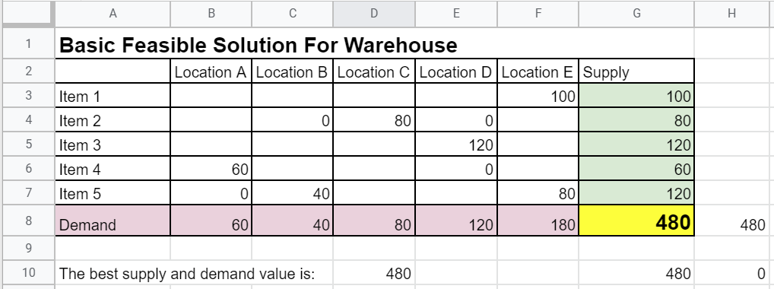

See above simple example. Any warehouse, Supply must equal to demand or very close. It is the best business solution.

### Task 3: Produce a Project Charter

Please view my project charter (here only show part):

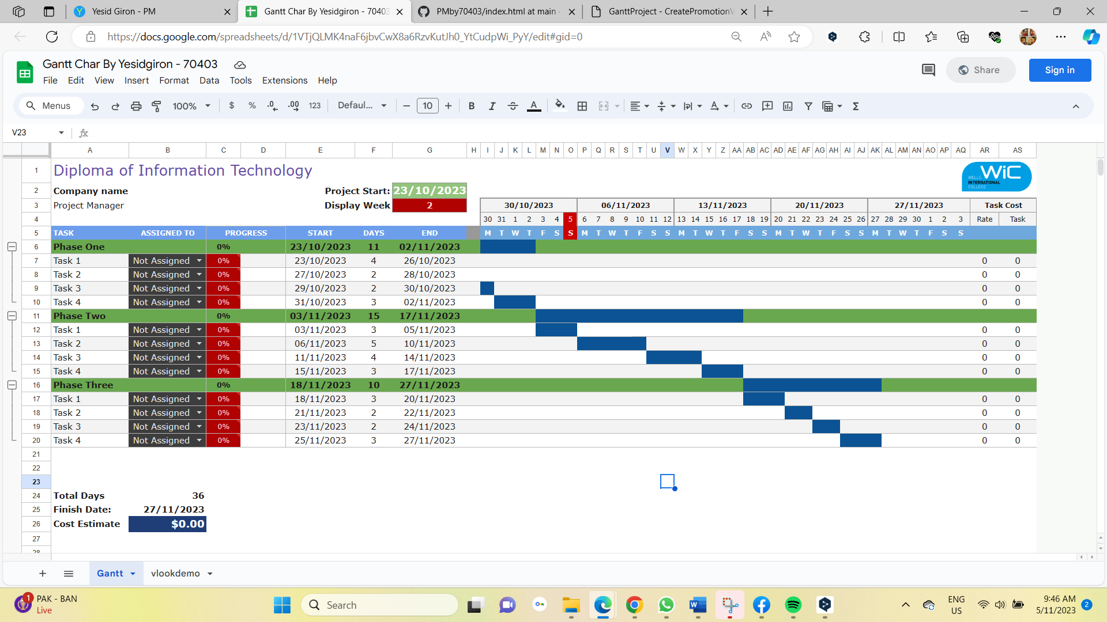

Develop a project charter for the Windsor project specifying project start date, finish date, approximate budget, project manager, project team with roles and responsibilities, project objective, project approach and stakeholders.

Name:

Description: Help business

Manager: John

Date Approved:

...

### Task 4: Project Document

Please check my site: <https://gironyess.github.io/PMby70403/>

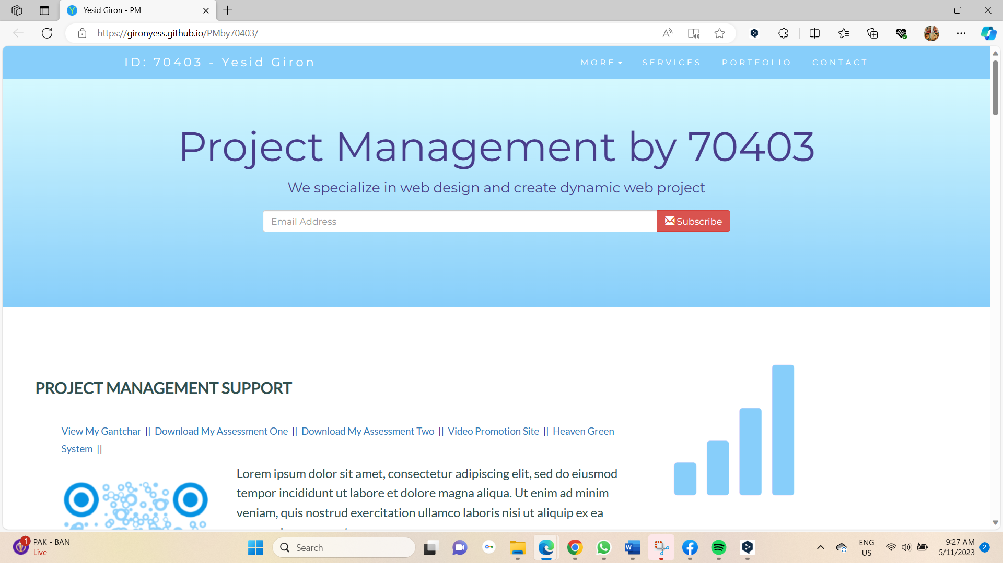

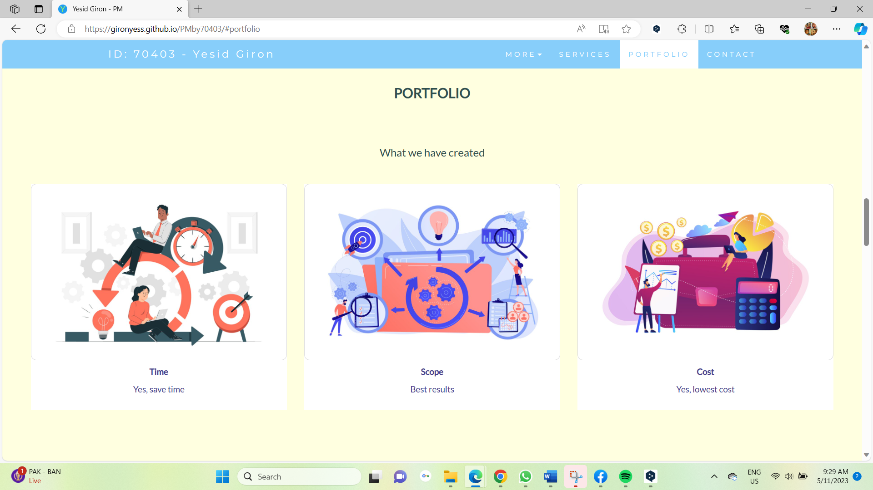

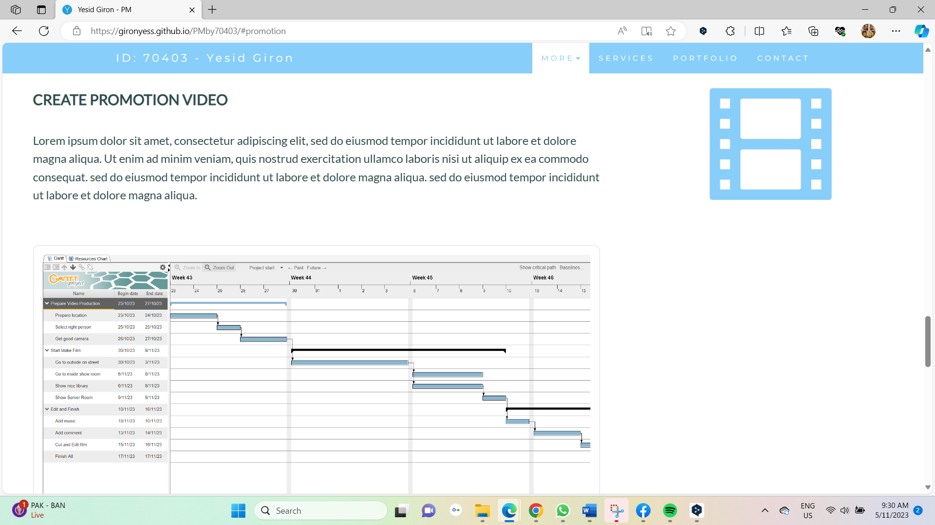

Refer to your current project, you have been asked to develop a project plan for WIC. Project plan outline as following:

In my Green project, I design following topics:

* Introduction (Select one recommendation from Task 2 for implement project plan)
* Project background

(Make promotion video for the college)

* Related factor to organization
* Scope and objective of the project
* Information gathering plan and approach
* Gathering method, can be one of the following
* Interview
* Questionnaire
* Observation
* Detail of information repositories
* Feasibility studies
* Technical
* Operational
* Economical
* Social
* Project plan and schedule (Development and Maintenance)
* Work breakdown structure
* Gantt Chart
* Milestone

Above last black diamond is the milestone!

* Project Deliverable
* Communication plan

Communication plan should include communication and consultation with all the relevant stakeholders. (From college learn guide)

* Deployment Plan (If needs)
* Training Plan (If needs)
* Recourse and budget, (budget has been limited by WIC Capital Expenditure of current fiscal year for Hardware $80,000, Software $10,000, and Outsourcing man-hours $100,000)

Above image is showing my current green project displaying part of budget!

* Risk Management
* Risk identified
* Contingency plan
* Change management
* Change control
* Conflict management

### Task 5: Project Closure

Prepare project closure document template as following:

* Project Sign-off document

When project sign off, it means your project finished. So you need make one clear sheet to tell everyone about your project. It will include:

* project start date
* project manager
* project finish date
* if something is going wrong
* ...

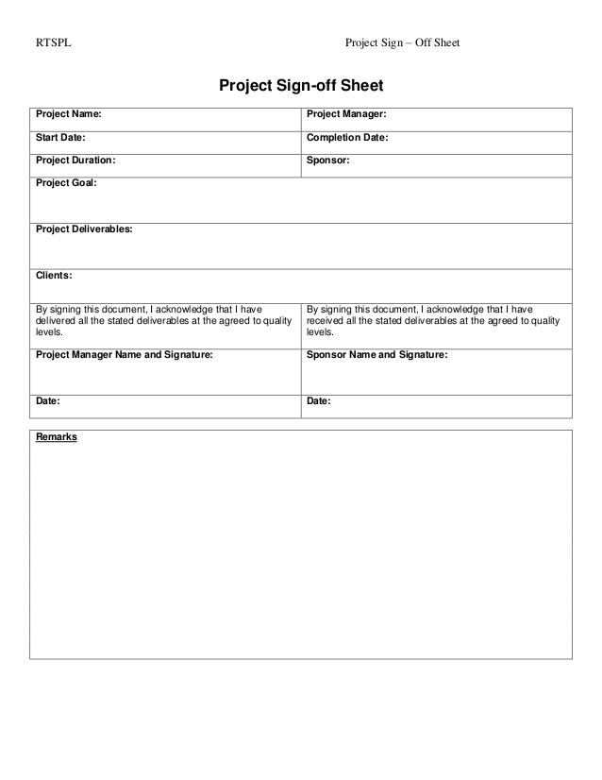

* Project evaluation document

You need show about your project, good or not enough. Summary all about your project

It may include:

* Budget evaluation
* Quality evaluation
* Benefit evaluation
* Etc...

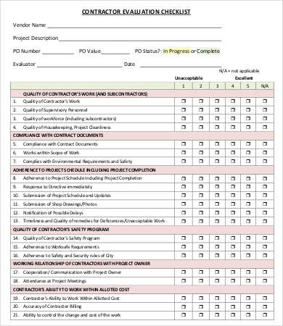

* Lesson learned template
* What we have learn through this project
* What we need to do if next project start
* What we learn some lesson. We could not make same mistake again.
* Etc.

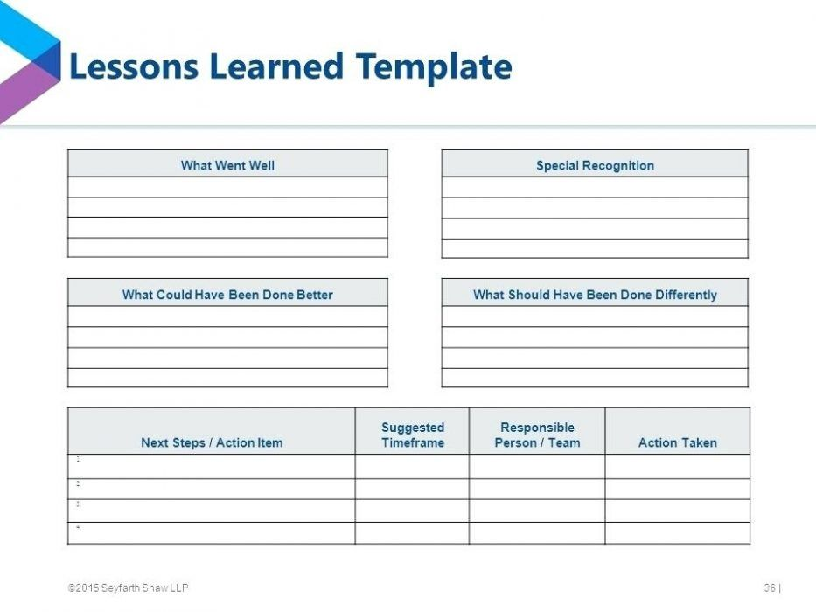

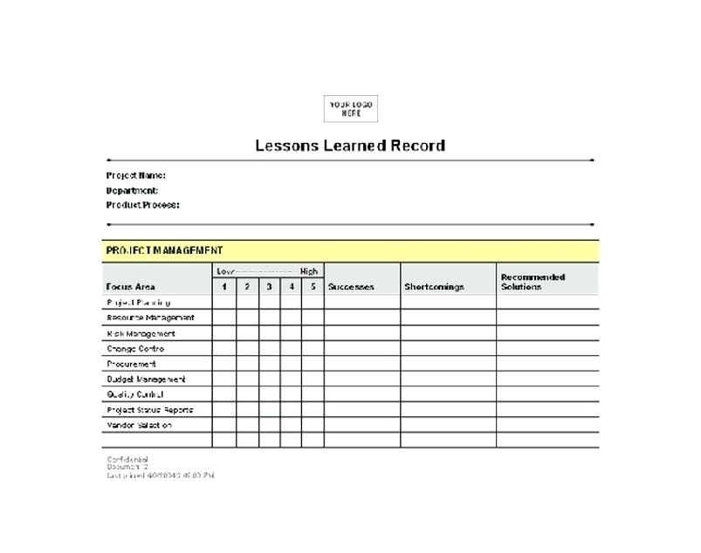

## Helpful web links to complete the assessment:

(1) How to Know When to Kill a Project & Cut Losses. https://www.projectmanager.com/training/how-to-know-when-to-kill-a-project.

(2) Kill Point In Project Management - Dee Project Manager. https://deeprojectmanager.com/kill-point-in-project-management/.

(3) Viewpoints - When to Terminate a Failing Project | PMI. https://www.pmi.org/learning/library/terminate-failing-project-manager-steps-3921.

(4) What you need to know about killing a project - MPUG. <https://www.mpug.com/killing-a-project/>.

(5) 5 Phases of Project Management Life Cycle You Need to Know. https://project-management.com/project-management-phases/.

(6) Project Completion – Project Management – 2nd Edition. https://opentextbc.ca/projectmanagement/chapter/chapter-18-project-completion-project-management/.

(7) The Project Life Cycle (Phases) – Project Management – 2nd Edition. https://opentextbc.ca/projectmanagement/chapter/chapter-3-the-project-life-cycle-phases-project-management/.

(8) Project management timeline: ordering all phases - PRINCE2. https://www.prince2.com/uk/blog/project-management-timeline.

(8) The Project Management Life Cycle Tutorial | Invenss Learning. https://www.invensislearning.com/blog/5-phases-project-management-lifecycle/.

## Search Index

B

Benefit evaluation 10

Budget evaluation 10

F

feasible solution 1, 4

P

project sign off 9

Q

Quality evaluation 10

S

same mistake 10

scenario 1

specific focus 2